Instructions for operating PFP Logger using Red Pitaya & MATLAB.

PFPCyberSecurity provides a simplistic data logger intended to provide users with the ability collect side channel data on their devices. Once the data has been collected the user simply uploads the data to the PFP Cloud Storage Server for analysis. The logger code base (source code) is available and can be modified by the user to satisfy their application specific requirements. The key components that the user must adhere to when modifying the code base is the data output format, which is in SigMF0.0.1PFPExtensionsV1.0.2 format.

The PFP Logger is written using MATLAB (R2016b), and Red Pitaya support functions. The logger basically operates similar to an Oscilloscope, but allows the user to setup up parameters such that the data collection is automated and capture waveforms are logged. MATLAB, and a Red Pitaya with PFP code installed are required.

**Typical collection process**

The typical data acquisition process is to repetitively sample waveforms for each State of the Device Under Test (DUT) that are of interest to the user. These repetitive waveforms will ultimately be used by for training by the SaaS Machine Learning analytics engine. The sampled time series of a State is referred to as a trace. Enough of these times series traces are collected in order to compute the required statistical characteristics of the given State. Ideally each cycle of the State will be identical within a reasonable amount of uncertainty but as with many systems the execution paths can be different due to interrupts, operating system schedulers, context switching, and other sub-systems within the DUT.

**Hardware Connections**

The following diagram shows the connection layout of an RF probe, amplifier, and Red Pitaya:

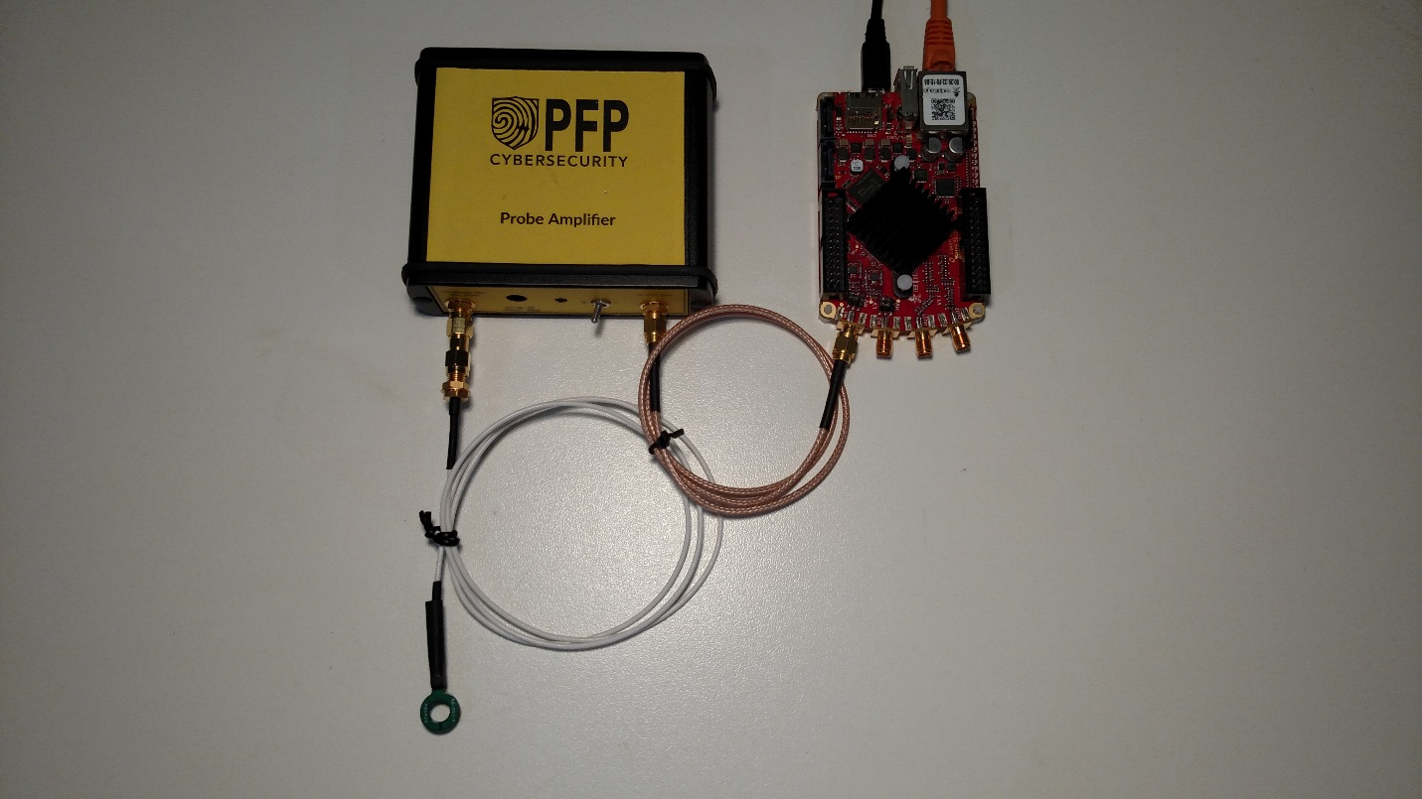

This diagram shows the connection layout attached to a micro controller ready for use:

To run the Logger.

1. Unzip the contents of the RPLogger.zip
2. Open MATLAB.
3. In MATLAB, navigate to the directory where “RPLogger” was extracted.
4. Make appropriate hardware connections.
5. At the MATLAB command prompt, type “RPLogger”, hit return. This should open the initial GUI.

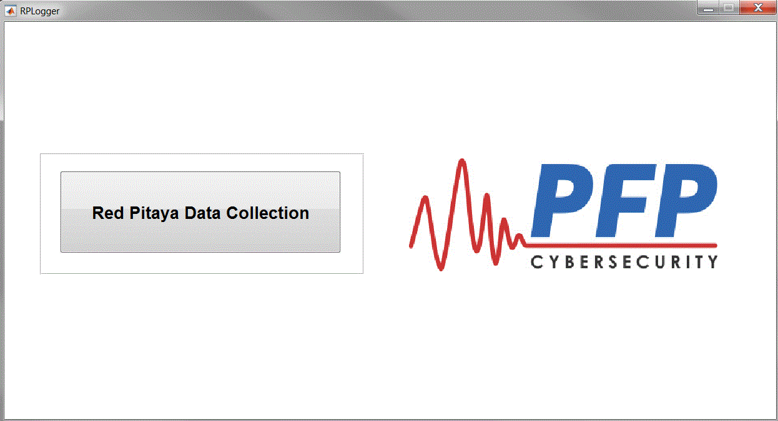

1. Click on the Red Pitaya Data Collection button. This will prompted the user to navigate to a directory where the Configuration file is located. A default Configuration file (rpDAQconfig.json) is located in the Support directory.

The configuration file contains setting for the initial configuration parameters for the logger. Do not open the file to make changes, changes are made using the supplied GUI.

1. After the user selects the configuration file, the following GUI should be open.

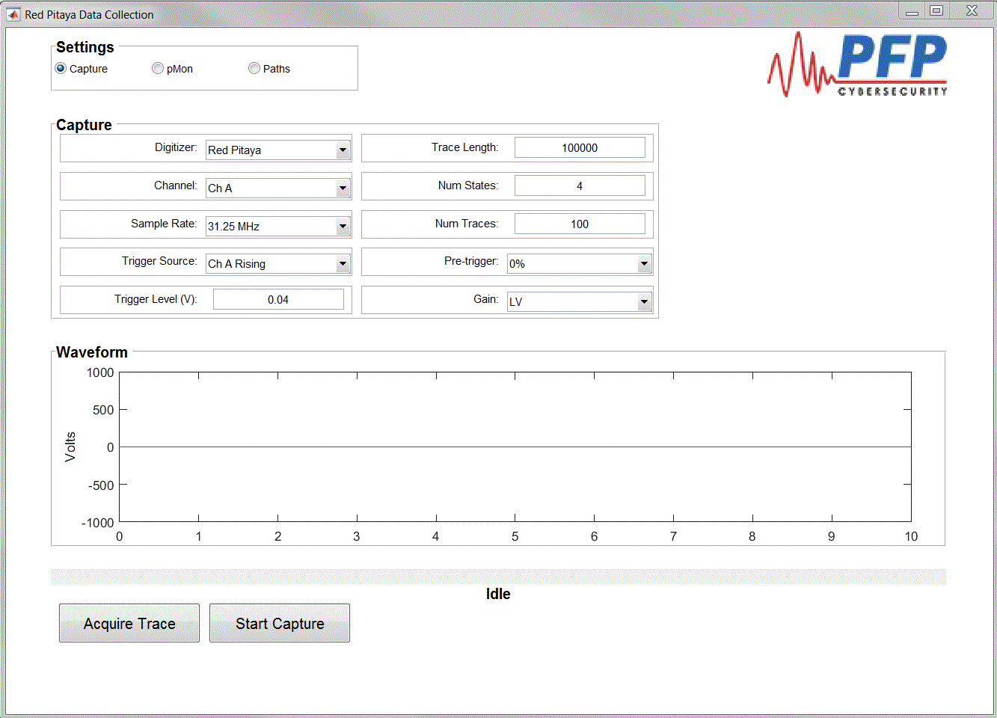

From the Red Pitaya Data Collection GUI, the user can modify the defaults file options, modify pMon connection options, configure the Red Pitaya, acquire individual traces for visual verification of setup or start the data collection process. If this is a new collection, it is advisable to first configure the Capture option to ensure the Red Pitaya is configured correctly for the user’s application. To configure pMon connection options select the “pMon” button in Settings. This will bring the user to the following GUI.

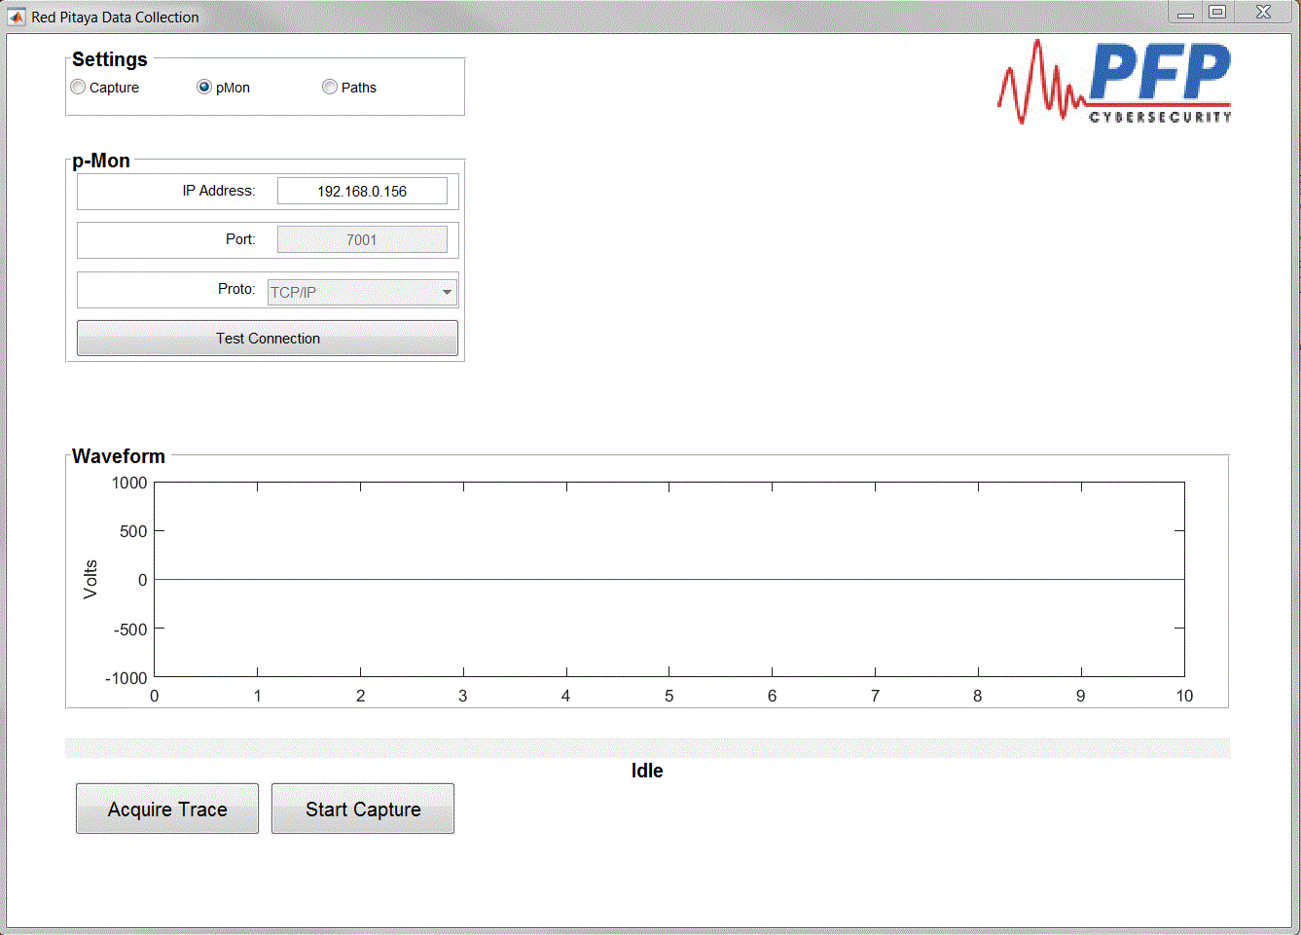

From this GUI the user can modify connection parameters, connection can be tested, and waveforms can be observed. Visually observing the waveforms can help ensure that the Red Pitaya is correctly setup to the application. Upon exiting the Red Pitaya Data Collection GUI, the user will be prompted to either save the current settings or discard them and bring the user back to the Data Collection GUI.

Once the logger has be properly configured an acquisition can be initiated by selecting the Start Capture button. The user will be prompted to that all data in the storage directory will be deleted.

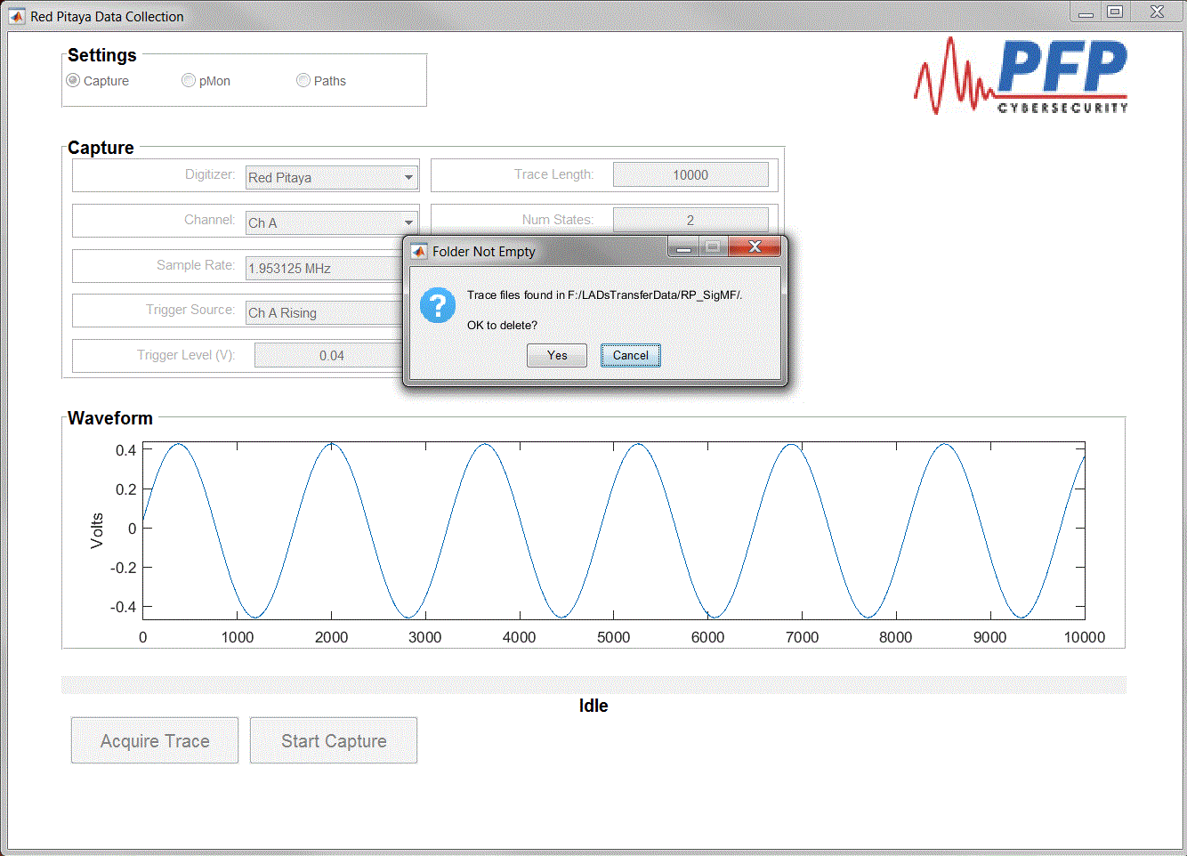

Next the logger will acquire the data for the initial State.

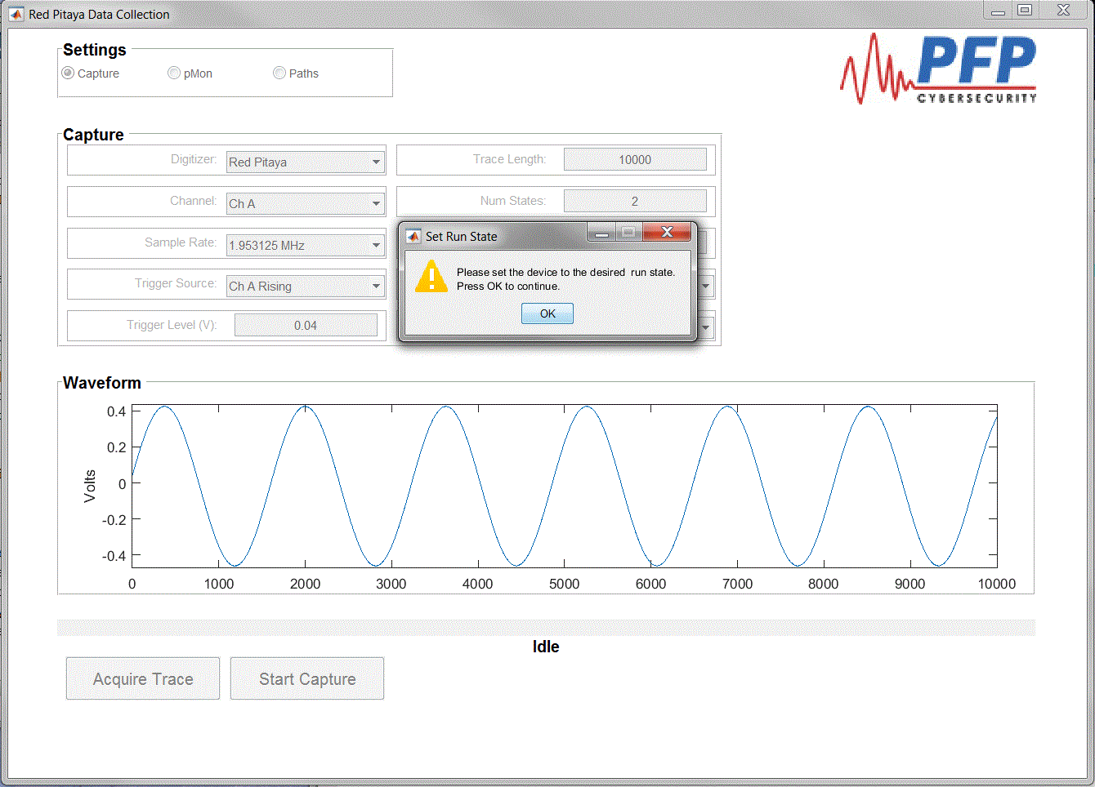

Once the data collection for the given State is completed the user will be prompted to change the DUT to the next State.

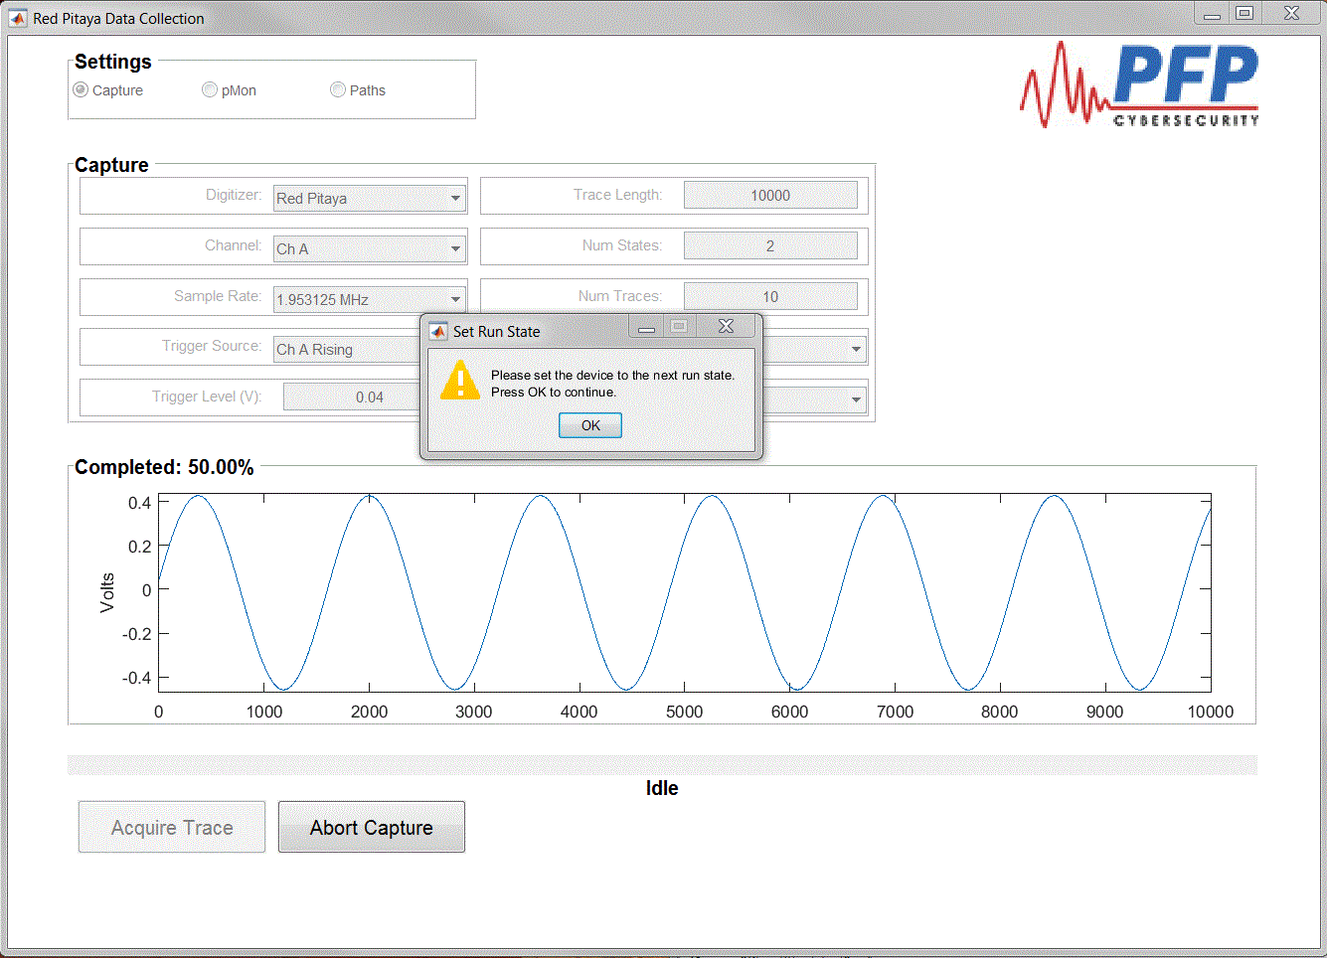

After all State data is collected the logger will prompt the user that the process is complete. The PFP Logger will write all the necessary files for analysis in the user specified directory.

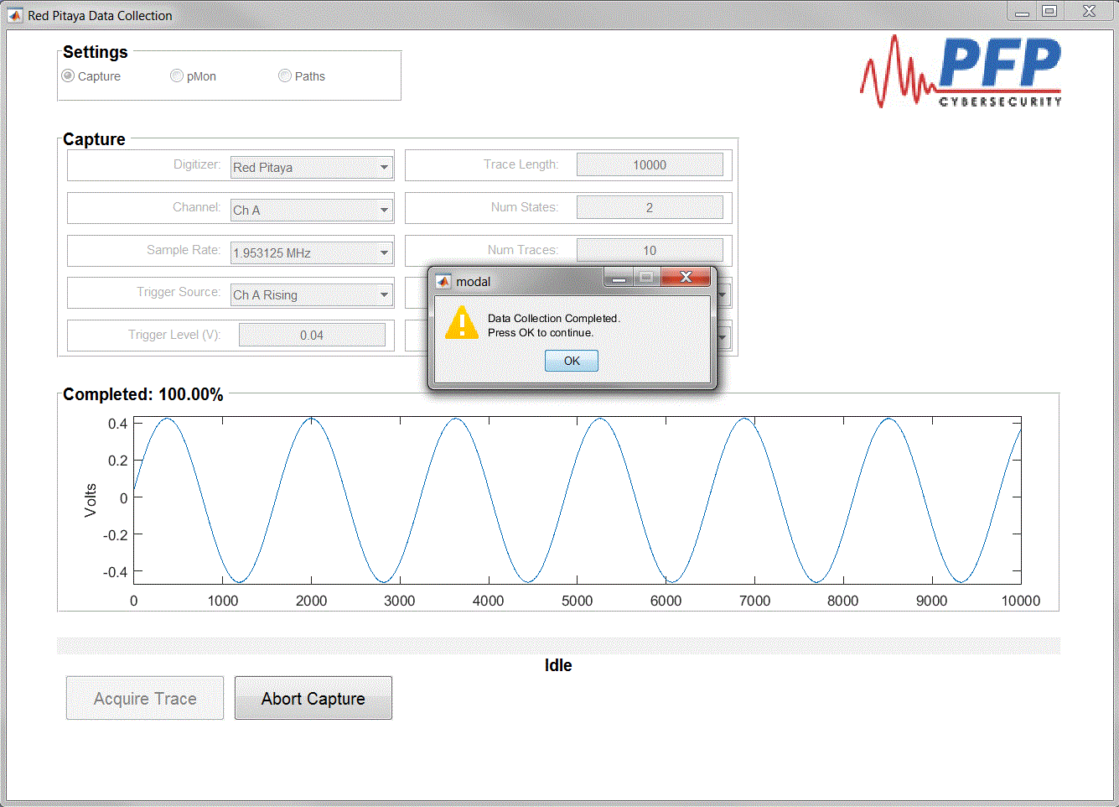

Once the user has collected all the necessary data for their application the logger can be shut down by simply closing the GUI windows. When closing the Red Pitaya Data Collection GUI the user will be prompted to save the current configuration.